Software Testing Assignment
Module-1(Fundamental)
- What is SDLC?
SDLC is a structure imposed on the development of a software product that defines the process for planning, implementation, testing, documentation, deployment and ongoing maintenance.

SDLC Phases

1. Requirements collection/gathering: Establish customer needs
2. Analysis : model and specify the requirements
3. Design : model and specify a solution
4. Implementation : construct a solution in software
5. Testing : validate the solution against the requirements
6. Maintenance : Repair defects and adapt the solution to the
Few Requirements.

- What is agile methodology?
Agile SDLC model is a combination of iterative and incremental process model with focus on process adaptability and customer satisfaction by rapid delivery of working software product.

- What is SRS?
A Software requirements specification (SRS) is a Complete Description of the behavior of the system to be developed.

- What is OOPS?
Object-Oriented Programming (OOP) is a programming Language model Organized around “Objects” rather than “Actions” and data rather than Logic.

- Write basic concepts of oops.
- Class
- Encapsulation
- Abstraction
- Polymorphism: 1. Compile time Polymorphism (Overloading) 2. Runtime Polymorphism (Overriding)
- Inheritance

- What is Object?
An object holds both variables and methods one object mind represent you a second object might represent me.
- What is class?
When defining a class we creating a new abstract data a type that can be treated
Like any other built in data type.

- What is encapsulation?
Encapsulation is the process of enclosing within classes and object the attribute and the methods.

- What is inheritance?
Inheritance means that one class inherits the characteristics of another class.

- What is polymorphism?
It allows different object to respond to the same message in different ways, the response specific to the type of the object.

- Write SDLC phases with basic Introduction.

1. Requirements collection/gathering: Establish customer needs
2. Analysis : model and specify the requirements
3. Design : model and specify a solution
4. Implementation : construct a solution in software
5. Testing : validate the solution against the requirements
6. Maintenance : Repair defects and adapt the solution to
The Few Requirements.
- Explain phases of the waterfall model.
The classical software lifecycle models the software development as a step by step waterfall between the various development phases.
Phases of the waterfall Model:
- Requirements collection
- Second Analysis
- Design
- Implementation
- Testing
- Maintenance

Advantages:
- Simple & Easy to understand and use.
- Phases are processed & completed one at a time.
- Clearly defined stages
- Works well for smaller projects where requirements are very well understood.
- Easy to arrange tasks.
- Process and results are well documented.
Disadvantages:
- High amounts of risk and uncertainty.
- No working software is produced until late during the life cycle.
- Poor model for long and ongoing projects.
- It is difficult to measure progress within stages.
- Cannot accommodate changing requirements.
- Adjusting scope during the lifecycle can end project.
- Not suitable for the projects where requirements are at a moderate to high risk of changing.

- Write phases of Spiral model.

  - Spiral model is very widely used in the Software industry as it is in synch with the natural development of any product.
Spiral Model Phases:
- Planning
- Risk Analysis
- Engineering
- Customer Evaluation

- Write Agile manifesto Principals.
- Agile SDLC model is a combination of iterative & increment process model with focus on process adaptability & Customer satisfaction by rapid delivery of working software product.
Agile Manifesto Principals.
- Individuals interactions
- Working Software
- Customer collaboration
- Responding to change

- What is RDBMS.
- What is SQL.
- Writ SQL commands.
- Write type of join.

- Draw use case on online book shopping.

  - 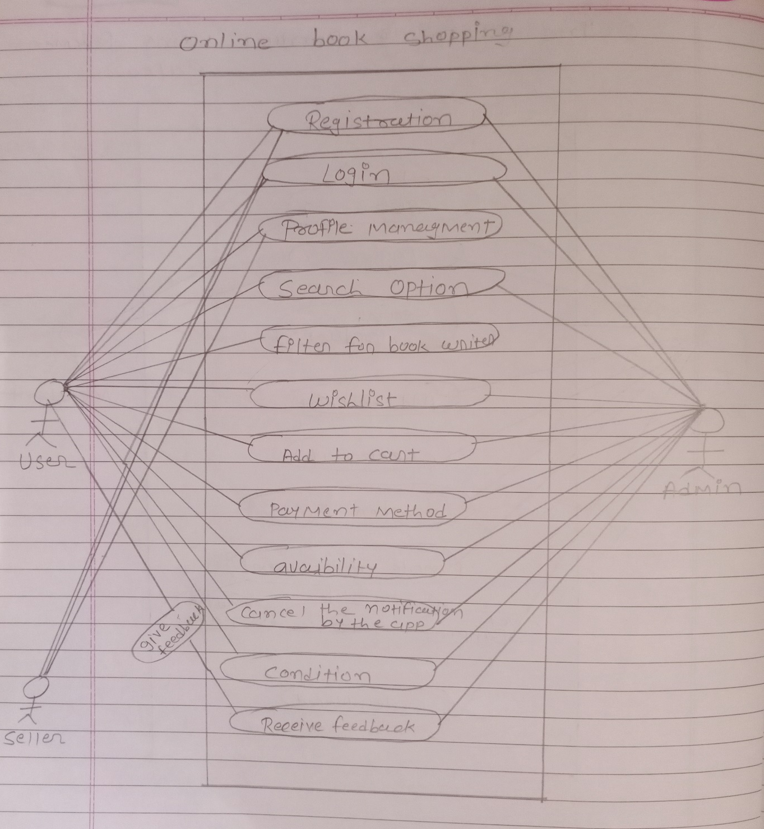

- Draw use case on online bill payment system (Paytm).

  - 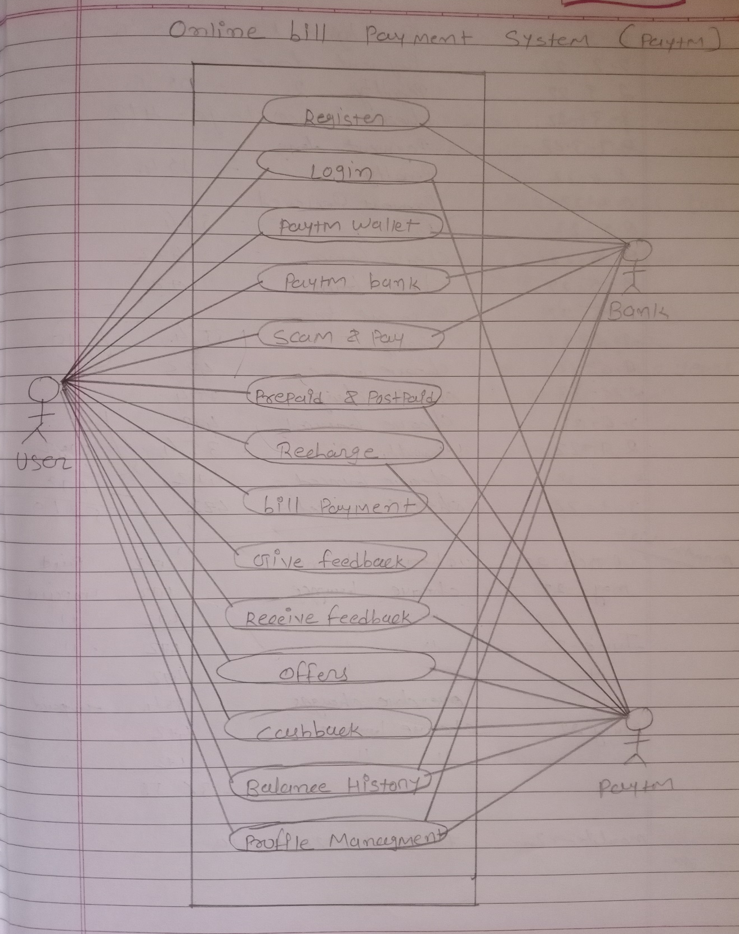

- Draw use case on online shopping Product Using COD.

  - 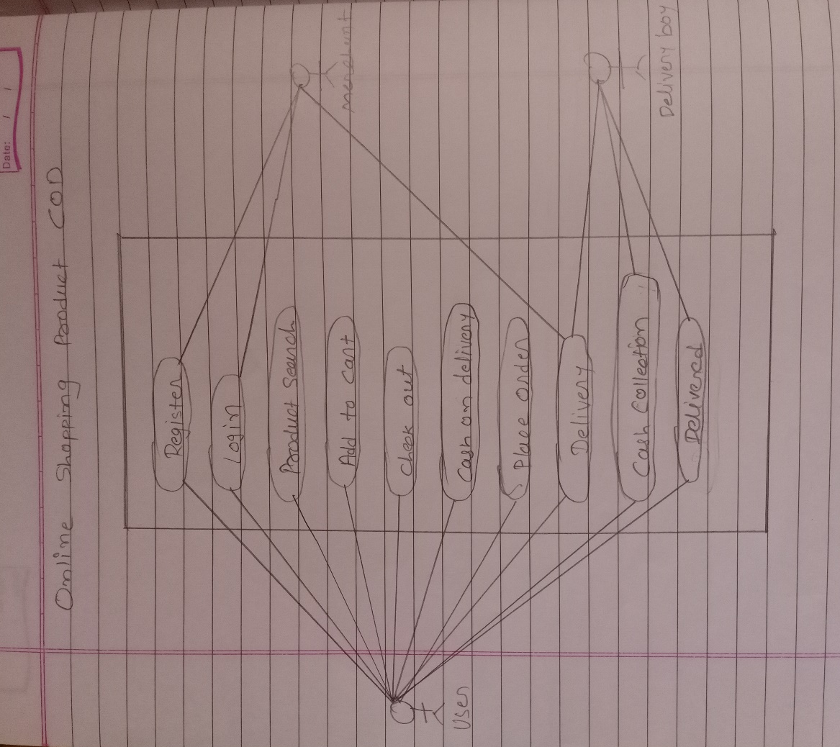

- Draw use case on online shopping product using Payment Gateway.

  - 